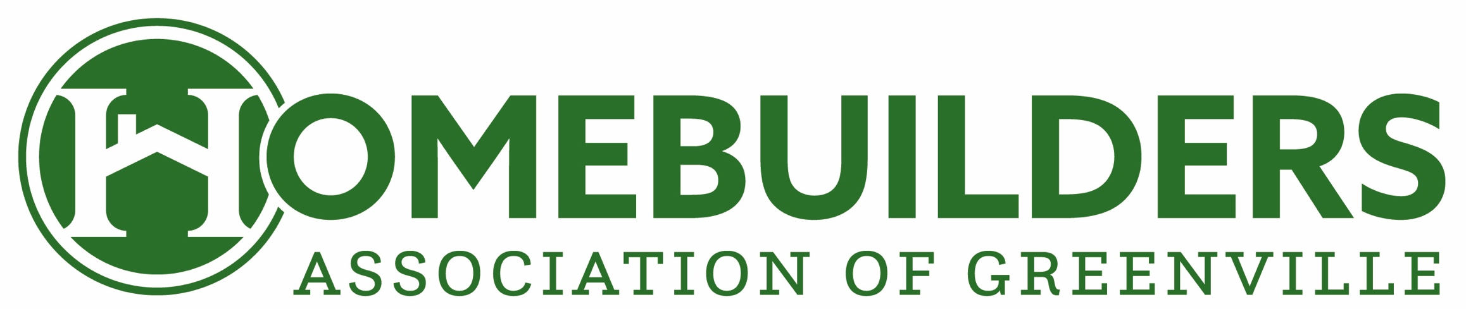

FOR IMMEDIATE RELEASE

Crescent Homes Recognized at the Ninth Annual Bridge Awards Gala

GREENVILLE, South Carolina [April 11,2022] – Crescent Homes was recently honored for its craftsmanship at the Home Builders Association of Greenville’s 2021 Bridge Awards Gala, Presented by GBS Building Supply, on Thursday, April 7, 2022. The company was awarded the awards for Best Kitchen, Best Bath, Best Exterior, and Best Overall for the Kerrington model at Macintosh in the $500k-$1m category.

“The Bridge Awards, a benchmark for the Home Builders Association of Greenville, allows us to recognize the best home building, remodeling, and craftsmanship in our industry, right here in the Upstate,” said Taylor Lyles, HBA of Greenville’s Chief Executive Officer. “The HBA of Greenville is excited to honor its membership with these awards as a testament to their craft and character in the industry.”

The Bridge Awards presented Crescent Homes with the awards for Best Kitchen, Best Bath, Best Exterior, and Best Overall for the Kerrington model at Macintosh in the $500k-$1m category.

The Home Builders Association of Greenville recognizes excellence in craftsmanship, service to the industry, commitment to the community, and member recruitment and retention, through the Bridge Awards. With a variety of recognition, the awards are divided among three main categories: individual, sales and marketing, and craftsmanship.

About the Home Builders Association of Greenville
The Home Builders Association of Greenville was founded on January 16, 1960. The association was officially organized and chartered as an affiliate of the National Association of Home Builders on that date in 1960. The association was formed so home builders and other professionals in the home building industry could work together and cooperate in promoting the industry, new homes, home remodeling, repairs and improvements, and other areas of interest to the home building industry. The association began with a few dedicated members and has grown to over 600-member firms today. For more information, please call 864-254-0133, or visit http://www.hbaofgreenville.com.

About Crescent Homes
Crescent Homes was brought to life in 2009 by Ted Terry, a fifth generation homebuilder with a vision and passion for designing homes and communities that evoke the charm of the Lowcountry. Ted’s vision for the company is to build thoughtful, livable and timeless homes.

